# PyTorch

查看NVIDIA GPU驱动版本

nvidia-smi

查看CUDA toolkit

nvcc -v

conda update conda

conda update anaconda

conda update python

conda update --all

conda config --add channels <https://mirrors.tuna.tsinghua.edu.cn/anaconda/pkgs/free/>

conda config --add channels https://mirrors.tuna.tsinghua.edu.cn/anaconda/pkgs/main/

conda config --add channels https://mirrors.tuna.tsinghua.edu.cn/anaconda/cloud/pytorch/

conda config --add channels https://mirrors.tuna.tsinghua.edu.cn/anaconda/cloud/conda-forge/

conda config --add channels https://mirrors.tuna.tsinghua.edu.cn/anaconda/cloud/msys2/

conda config --set show_channel_urls yes

conda config --remove channels https://mirrors.tuna.tsinghua.edu.cn/anaconda/cloud/conda-forge/

conda config --show

conda create –n pytorch python=3.6

conda activate pytorch

conda deactivate pytorch

conda install pytorch torchvision torchaudio cudatoolkit=10.2 –c pytorch

python

import torch

print('gpu:', torch.cuda.is_available())

# Sekiro

conda create –n sekiro python=3.7

conda activate sekiro

查看tensorflow-gpu与cuda的适配版本

<https://tensorflow.google.cn/install/source?hl=en#linux>

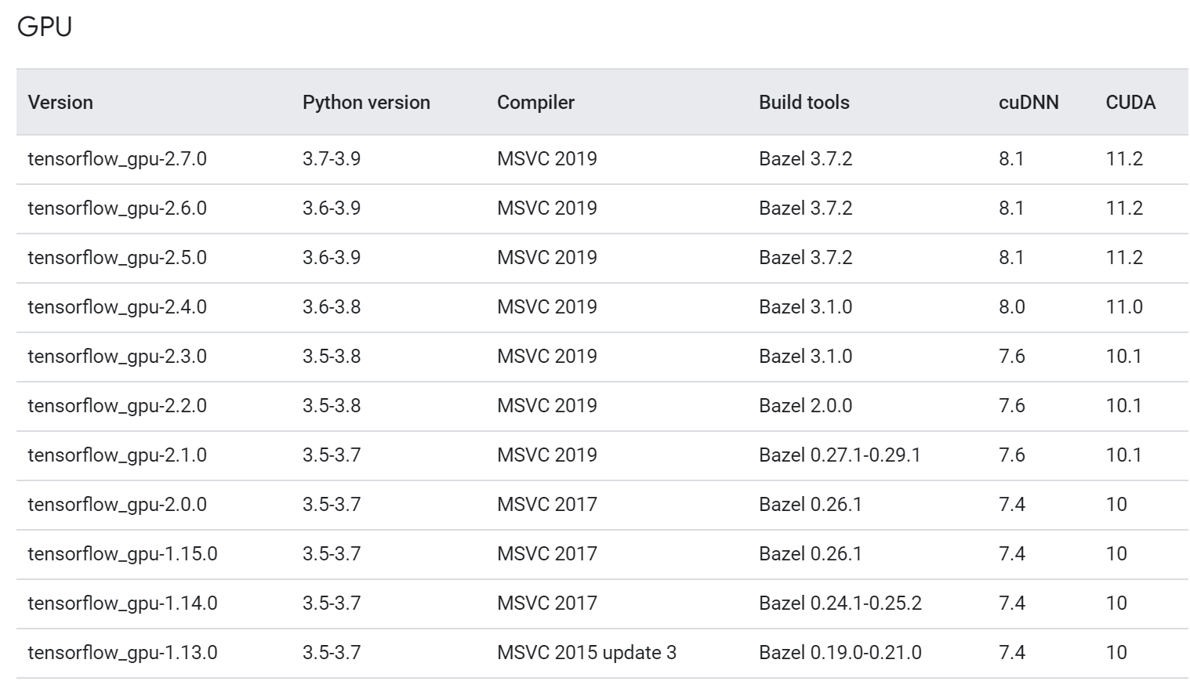

CUDA 10.2

cuDNN 7.6

conda search tensorflow-gpu

conda install tensorflow-gpu=2.3.0 –y

conda install opencv=4.5.3

conda install pillow

conda install pywin32

conda install gym=0.18.0

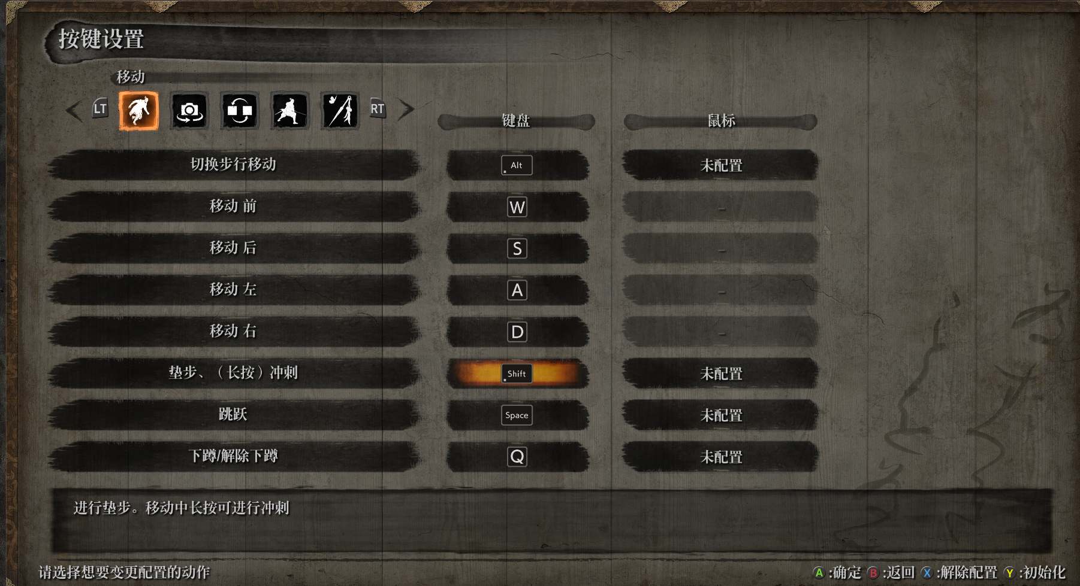

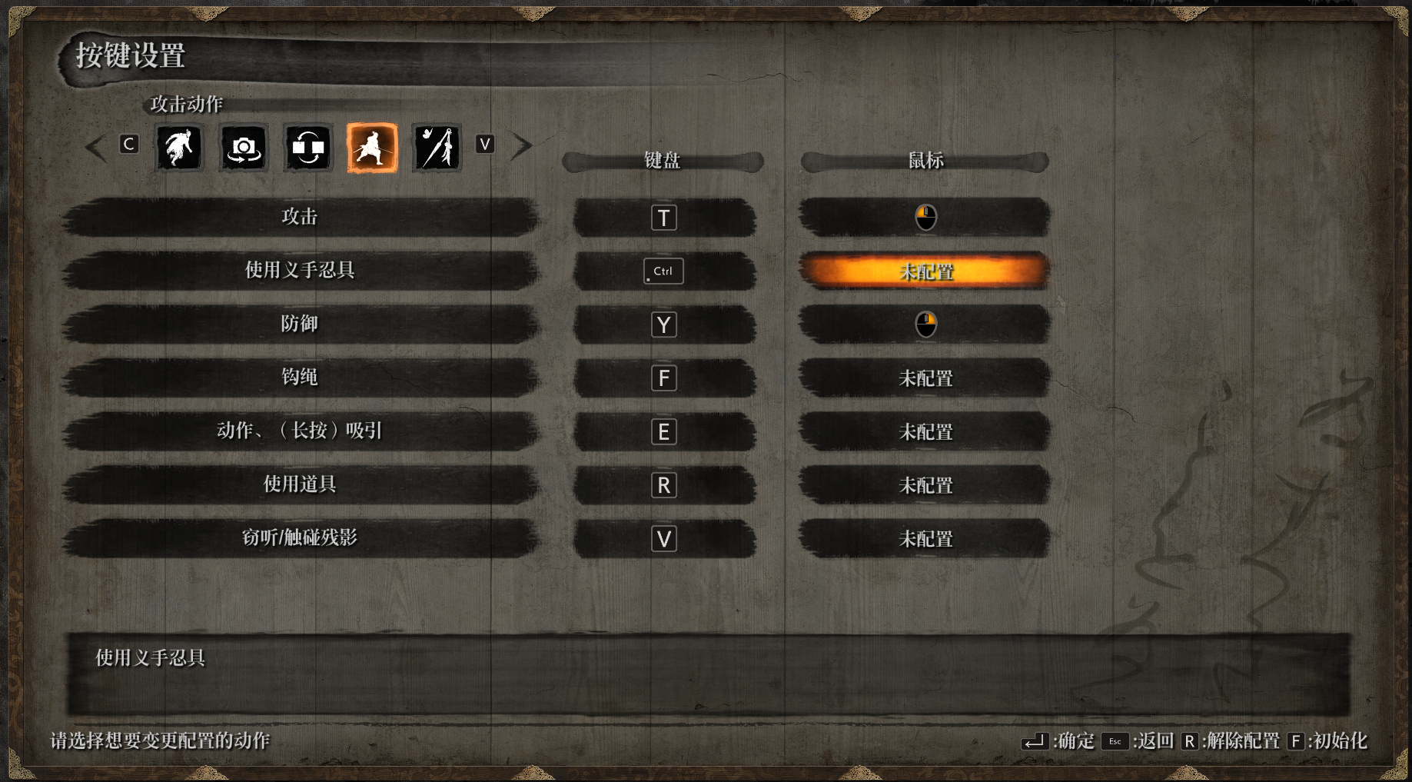

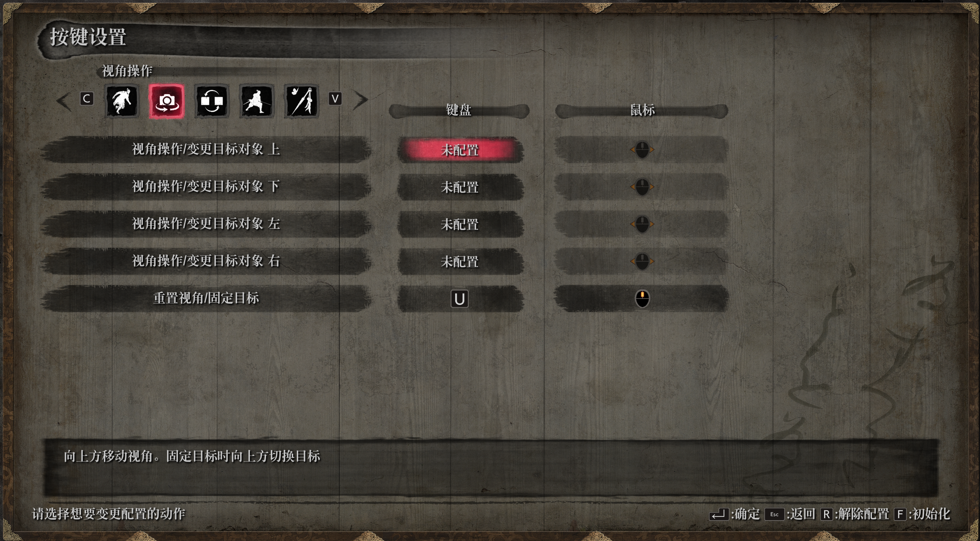

存档文件位于

C:\Users\Administrator\AppData\Roaming\Sekiro

OCR环境搭建

安装Tesseract

下载64位

<https://github.com/UB-Mannheim/tesseract/wiki>

C:\Users\Administrator\AppData\Local\Programs\Tesseract-OCR>tesseract

tesseract --list-langs

1. Choose the additional language and script models from e.g. one of the places linked from <https://github.com/tesseract-ocr/tesseract/wiki/Data-Files> .
2. https://tesseract-ocr.github.io/tessdoc/Data-Files
3. Download the traineddata file to the tessdata folder of tesseract on your PC, e.g. C:\Program Files\Tesseract-OCR\tessdata. It is also possible to create new subfolders within that folder to distinguish for example the best and fast models.
4. Check that the new languages are recognized by

tesseract --list-langs

修改

D:\ProgramData\Anaconda3\envs\sekiro\Lib\site-packages\pytesseract\pytesseract.py

tesseract_cmd = 'C:\\Users\\Administrator\\AppData\\Local\\Programs\\Tesseract-OCR\\tesseract'

https://blog.csdn.net/dvd_sun/article/details/105394873